Recipient:

«Title» «First_name» «Last_name»
«Institute_or_company»
«Address_1»
«Adress2_if_address_1_is_too_long»
«Zip_code» «Town»
«Country»

Dear «Title» «First_name» «Last_name»

The PCR Tokyo Valves’ Course Directors cordially invite you to attend PCR Tokyo Valves 2025 taking place from 7 to 9 February 2025 at the following address:

Toranomon Hill 〒105-6390 Tokyo, Minato City, Toranomon, 1 Chome−23−1 ~4号Japan.

Passport details:

Date of Birth:
Passport Number:
Passport Expiry Date:
Passport issued in:
Citizenship:

This invitation letter should not be considered as any commitment towards your travel, accommodation, and registration costs.

We thank you for your interest in participating in PCR Tokyo Valves 2025 and look forward to welcoming you in Tokyo!

Best regards,

Tokyo, on Date

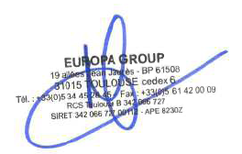

Contact: sec-tokyovalves@congre.co.jp

